THE EFFECTIVE DATE OF THIS APPLICATION IS AUGUSTI I, 2021 TO AUGUST 30, 2031
Renewal of this Brand/Mark must be filed during the period August 31, 2021 to February 28, 2022 This form shall only be used to record a single brand or mark for one or more locations on an animal.
Please print or type in formation (* Required Information):
The undersigned hereby makes application for the registration and recording of the following mark(s) and/or brand(s) by the County Clerk of *CORYELL County, Texas

*New:
Contact Information:
*Owner/Agent:
Ranch/ Business Name:
*Address:
Renewal: Release: Transfer:

*City: *State: *Zip:
Phone: NIA Email:
Brand /Mark Information: Male: Female:
*Specie: Cattle: Horse: Swine: Sheep: Goat: Ear Marks Only:
Volume/Book: Page: 0 Cert.#:
BRAND MARK

Draw the Brand | Right Ear Left Ear
□ | 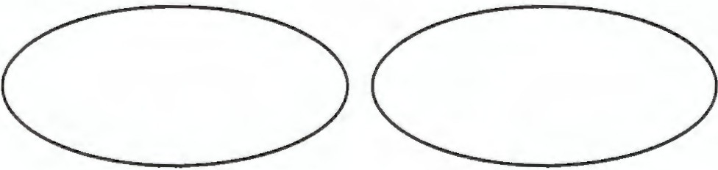
*Brand Location on Animal:
□
Left All Locations | Thigh Electronic Chip #:
Right Should er  Side / Rib | Jaw/ Face / Nose  Tail/ Back
Flank | Other:

*Brand Description:
Hip/ Loin Tattoos:

*Signature of Applicant *Date: _ (Owner/Agent)
*By: -----------Deputy: * JENNIFER NEWTON County Clerk

THE EFFECTIVE DATE OF THIS APPLICATION IS AUGUSD I, 2021 TO AUGUST 30, 2031
Renewal of this Brand/Mark must be filed during the period August 31, 2021 to February 28, 2022
This fom1 shall only be used to record a single brand or mark for one or more locations on an animal.
County Seal
Pursuant to Texas Agriculture Code 144.041, a copy of this application shall be forwarded to Texas and Southwestern Cattle Raisers Association.

Email: brands@tscra.org Fax: 817-887-4402
Mail PO Box 101988, Fort Worth, TX 76185 Phone: 800-242-7820

BEFORE ME (signator’s name here) ____________________________________________ PERSONALLY APPEARED AND ACKNOWLEDGED THE ABOVE INFORMATION TO BE TRUE AND CORRECT: SWORN TO AND SUBSCRIBED BEFORE ME THIS _____DAY OF ____________________, 20______.

SEAL ______________________________________________
NOTARY PUBLIC STATE OF TEXAS

